# FULL STACK DEVELOPMENT WITH MERN

1.INTRODUCTION:

Project Title : BookNest : Where Stories Nestle

Team Members : Mounika Velpula,

Akkala Nandini,

Pushpavalli Lakshmipuram

2.Project Review:

Purpose : Premier digital bookstore for discovering literary adventures Features a hero section with bookstore imagery

* Displays featured books and book categories
* Provides a complete book browsing experience with header navigation and footer
* Built as a responsive React application using modern web technologies

Features:

🔍 Navigation & Search

* Sticky header with logo and navigation
* Search functionality (books, authors, genres)
* Responsive navigation menu
* Mobile-optimized search bar

🛒 Shopping Experience

* Shopping cart with item counter badge
* User account access
* Mobile hamburger menu

🏠 Hero Section

* Compelling tagline: "Where Stories Nestle"
* Call-to-action buttons (Explore Collection, View Bestsellers)
* Social proof (50K+ Happy Readers, Book Club approval)
* Promotional banner (30% Off Fiction)

📚 Book Discovery

* Featured book collection with 6+ curated titles
* Book cards showing ratings, reviews, prices, genres
* Bestseller & new release badges
* Price comparison (original vs sale price)

🎯 Category Browsing

* 6 genre categories: Fiction, Romance, Thriller, Biography, Mystery, Comedy
* Book count per category
* Interactive hover effects
* Genre descriptions and visual icons

📞 Customer Support

* Contact information (phone, email, address)
* Customer service links (Help, Shipping, Returns, etc.)
* Newsletter subscription
* Social media integration (Facebook, Twitter, Instagram)

🎨 Design Features

* Responsive design for all devices
* Dark/light mode compatibility
* Smooth animations and transitions
* Modern UI with Tailwind CSS and shadcn components

BookNest Project Features:

🔍 Navigation & Search

* Sticky header with logo and navigation
* Search functionality (books, authors, genres)
* Responsive navigation menu
* Mobile-optimized search bar

🛒 Shopping Experience

* Shopping cart with item counter badge
* User account access
* Mobile hamburger menu

🏠 Hero Section

* Compelling tagline: "Where Stories Nestle"
* Call-to-action buttons (Explore Collection, View Bestsellers)
* Social proof (50K+ Happy Readers, Book Club approval)
* Promotional banner (30% Off Fiction)

📚 Book Discovery

* Featured book collection with 6+ curated titles
* Book cards showing ratings, reviews, prices, genres
* Bestseller & new release badges
* Price comparison (original vs sale price)

🎯 Category Browsing

* 6 genre categories: Fiction, Romance, Thriller, Biography, Mystery, Comedy
* Book count per category
* Interactive hover effects
* Genre descriptions and visual icons

📞 Customer Support

* Contact information (phone, email, address)
* Customer service links (Help, Shipping, Returns, etc.)
* Newsletter subscription
* Social media integration (Facebook, Twitter, Instagram)

🎨 Design Features

* Responsive design for all devices
* Dark/light mode compatibility
* Smooth animations and transitions

3.Project Review:

Front End:

Client (Browser)

↓

React Frontend (Vite + React + Tailwind CSS)

↓

Node.js + Express.js Backend API

↓

MongoDB Database (Cloud / Local)

Back End:

/backend

│

├── config/

│ └── db.js → MongoDB connection setup

│

├── controllers/ → Logic for each route

│ ├── authController.js

│ ├── bookController.js

│ └── orderController.js

│

├── middleware/

│ ├── authMiddleware.js → Verify JWT token

│ └── errorHandler.js → Centralized error handler

│

├── models/ → Mongoose schemas

│ ├── User.js

│ ├── Book.js

│ └── Order.js

│

├── routes/

│ ├── authRoutes.js

│ ├── bookRoutes.js

│ └── orderRoutes.js

│

├── utils/

│ └── generateToken.js → JWT token creation

│

├── .env

├── server.js → App entry point

└── package.json

DataBase:

{

"_id": "64ef9a5c9f31a67...",

"userId": "64ef98c4c90a...",

"orderItems": [

{

"bookId": "64ef8ffdd5f...",

"title": "The Alchemist",

"price": 300,

"quantity": 2

}

],

"totalAmount": 600,

"orderStatus": "Confirmed",

"createdAt": "2025-07-19T10:45:00Z"

}

4.setup instructions:

Prerequistics: 👉 Knowledge of HTML, CSS, JavaScript (ES6+), React.js, Node.js, Express.js, MongoDB, Mongoose, REST APIs, JWT authentication, Git, and basic deployment tools like Vercel and MongoDB Atlas.

Installations:

1. **Install Node.js** and create frontend using Vite (npm create vite@latest booknest -- --template react) and backend using Express (npm init -y, install dependencies).
2. **Set up MongoDB** locally or on Atlas and configure the .env file with MONGO_URI, JWT_SECRET, and PORT.
3. **Run frontend** with npm run dev and **backend** with node server.js or nodemon server.js.

5.Folder Structure:

Client: **booknest/** → contains client/ (React frontend), server/ (Node.js + Express backend), and shared files like .gitignore, README.md, and .env.

Ask ChatGPT

Server:👉 **server/** → contains controllers/, routes/, models/, middleware/, config/, .env, and server.js.

6.Running The Applications:

Front end:npm start in the client directory

Back end:npm start with the server directory

7.API Documentation:

**BookNest API** supports user authentication (/api/auth), book operations (/api/books), and order management (/api/orders).  
Use methods like POST, GET, PUT, and DELETE with JWT-protected routes for secure interactions.

8.Authentication:

Implement user registration and login using bcrypt password hashing and jwt for generating authentication.

9.Screenshots:

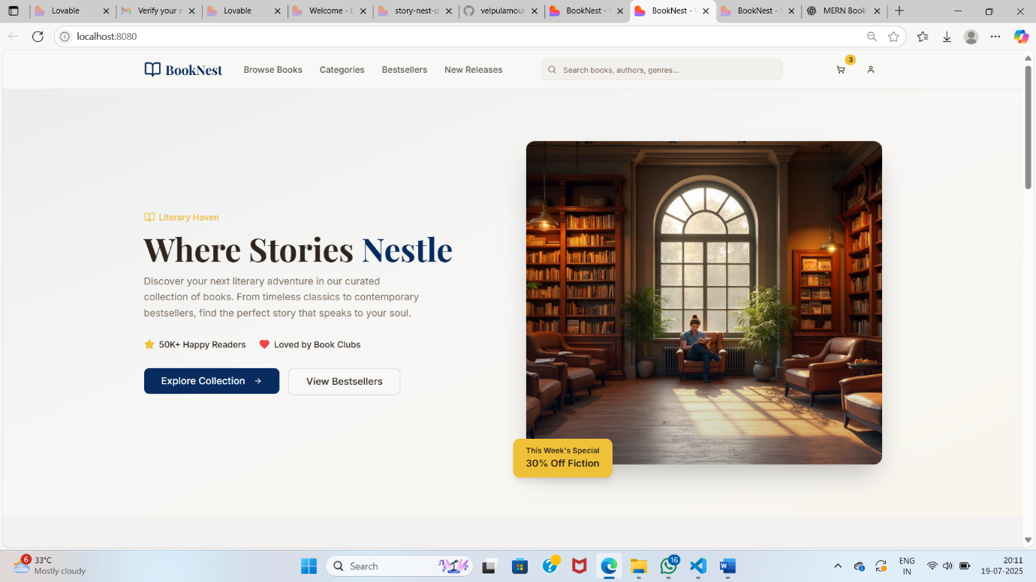

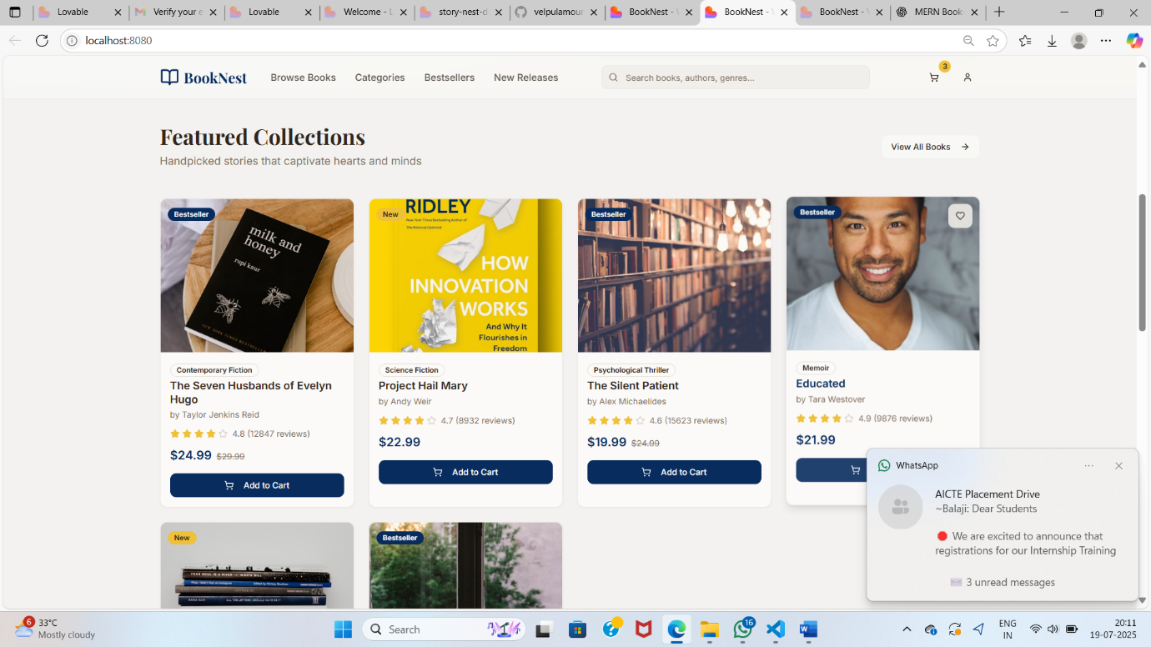

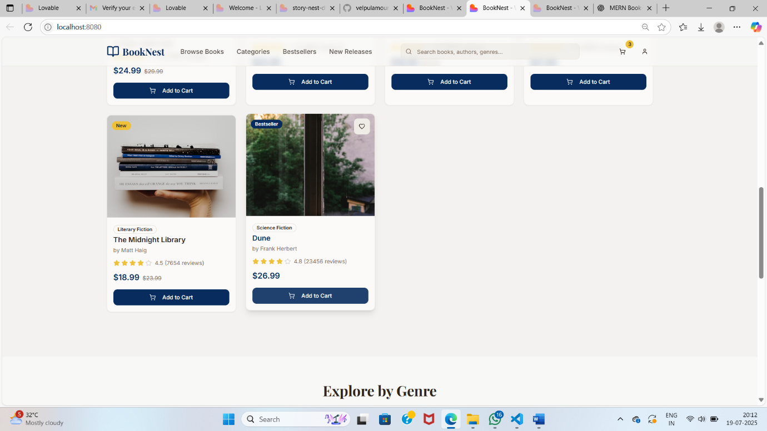

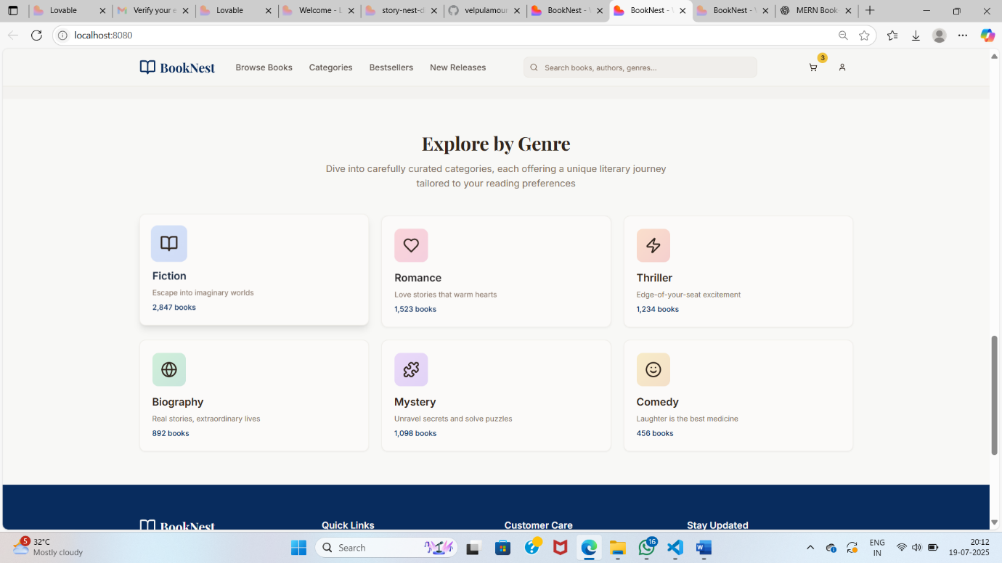

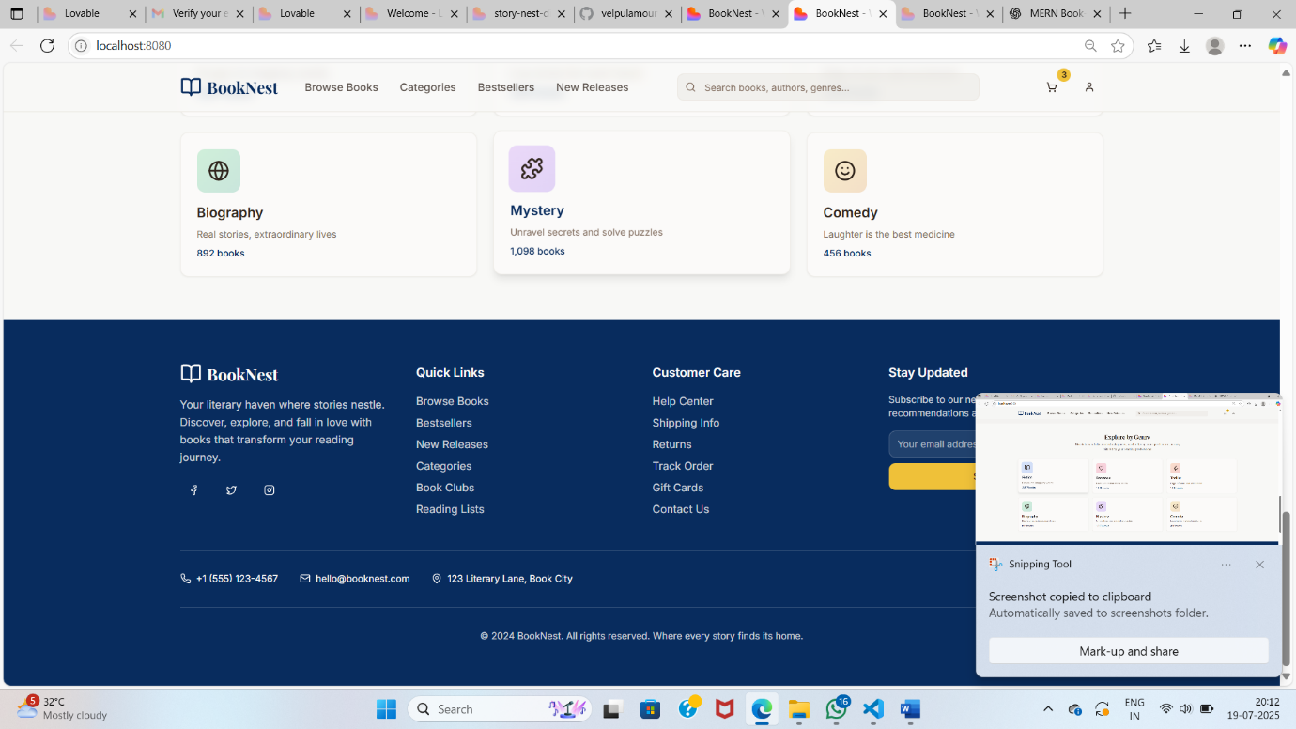

10.Testing:

Use jest and supertest to perform unit and integration testing for backend APIs ,ensuring reliability and correctness of authentication and routes.

11.Future Enhancements:

Future enhancements include adding OAuth (Google/GitHub) login, email verification, password reset, user roles (admin/customer), and two-factor authentication (2FA) for improved security and user experience.

THANK YOU